# Citiq Tech Challenge

## Proposed System Architecture

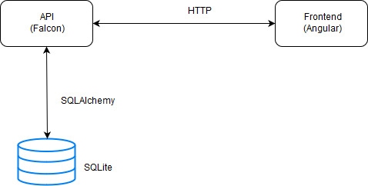

Figure :The proposed system architecture

## Frontend

Front should contain a login for which the user’s details may be authenticated. If authentication is successful, the User may scroll through a panel in which contains the groups that the user is participating in. Thereafter, the user may view the posts from each group. Partial implementation of this is found in the “app” folder.

## API

The API contains resources for Users, Posts, Votes and Logins. It handles the mainly the HTTP POST, GET, PUT and DELETE requests and provides responses. Implementation may be found in resources.py.

## Database

The database consists of two main tables namely the Users and the Posts Tables. The Users Table stores information concerning a user while the Posts tables stores all relevant information about a post. The Class diagram below shows the metrics stored for each class. Implementation of these may be found in models.py.

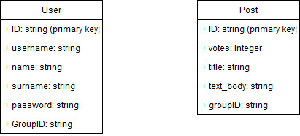

Figure :The objects to be stored in the database